Motor Sizing Software

User Manual: PBA System

Version 4

Topra World Pte Ltd

8 Eu Tong Sen Street

#14-94

The Central

Singapore 059818

**IMIT (Pvt) Ltd**

**No 82, Galle Road , Colombo 04, Sri Lanka**

**Phone: (+94)719927926 Fax: (+94)115926926**

**Web :www.imit.lk Contact: info@imit.lk**

Contents

Motor Sizing Software 1

User Manual: PBA System 1

Revision History 3

Main Interface 4

1.Main Banner 4

About PBA 5

Motor Sizer Interface 6

1.Project/Machine 7

Fields 7

Buttons 7

Functions 7

Validations 9

2.Axis 10

Buttons 10

3.Profile Grid 11

Buttons 11

Functions *Mutli record Selection* 11

4.Final Profile 13

5.Recommended Motors 13

6.Selected motors Motors 13

6.Final calculation based on the Selected Motor 13

8.Servo Drive 14

Revision History

|  |  |  |
| --- | --- | --- |
| **Name** | **Date** | **Remarks** |
| Lakmal | 07th April 2021 | Initial Document**,** Application Inerface |
| Lakmal | 01st June 2021 | Initial Calculations including Linear and Rotary motors |
| Lakmal | 11th June 2021 | Completed motor lists and all the calculations for rotary and Linear except two motor categrories |
| Lakmal | 10th July 2021 | Completed the motot size calculations |
| Lakmal | 14th Aug 2021 | Updated to latest user intefaces. |
| Lakmal | 10th Oct 2021 | Included the latest changes and main window interface |

# Main Interface

1

2

1. Main Banner

2. Transaction Area

## 1.Main Banner

Main banner holds the PBA logo and other information.

If the application cannot connect to the server this will be Offline.

When click application try connect to the server and check the server master data vrsion. If new version exists will prmpt to user to download

User always will be Guest .

This fuction doesn’t applicable for normal user

Indicate the master data version that holds in PBA server. When master data changed by the PBA team then new master data version will be generated

Indicate the master data version that holds in the user machine

Shows the current application version. PBA will release the new version whenever there’s a change

### About PBA

About PBA button will popup and application and provides the information about PBA and links to PBA materials.

Motor Sizer Interface

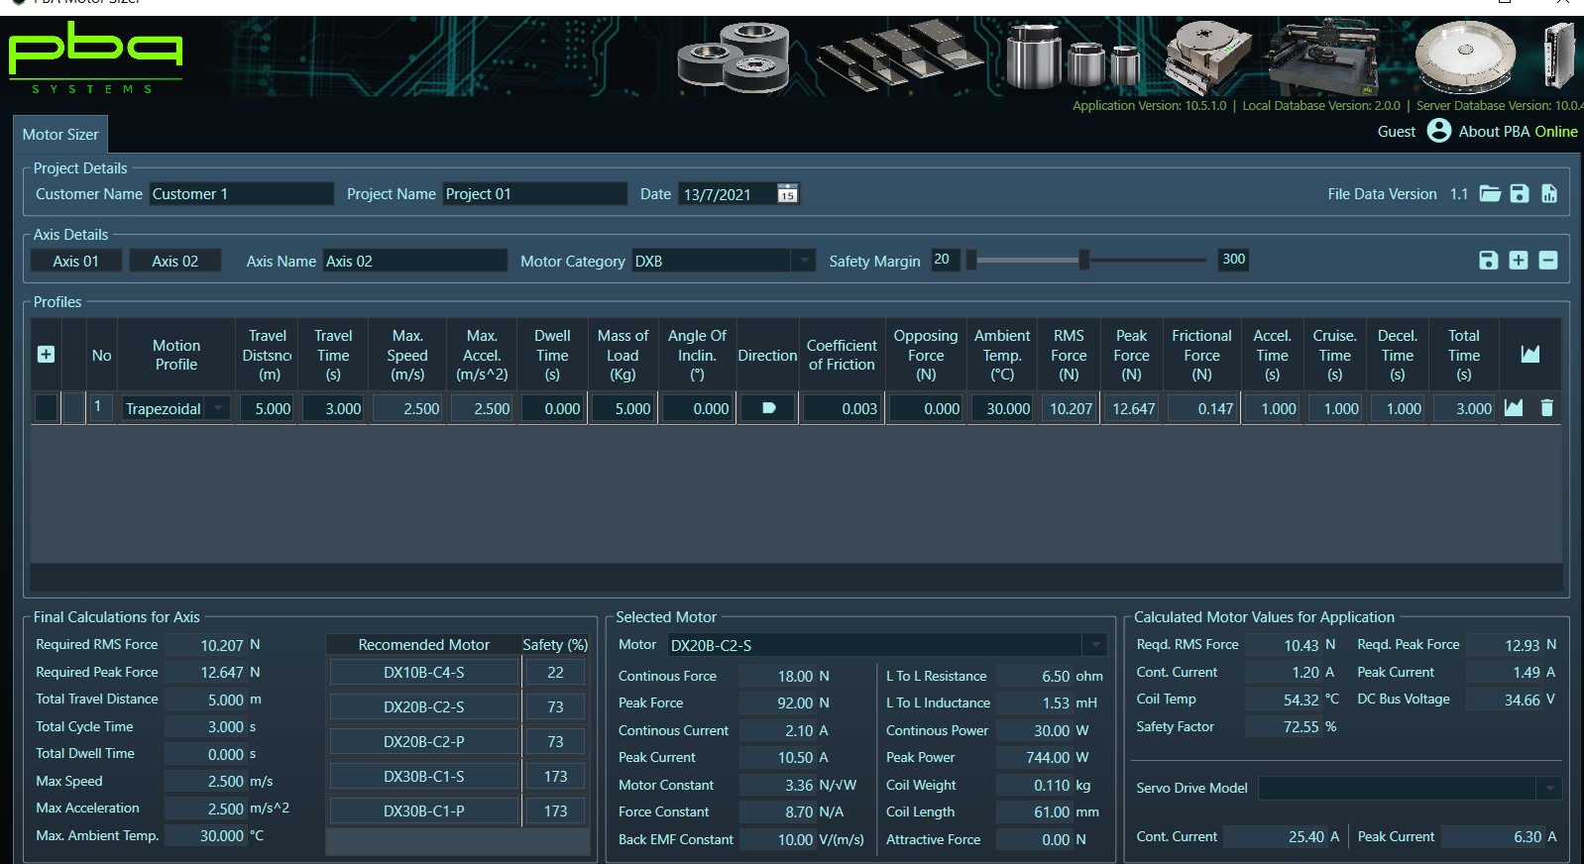

1

2

6

3

5

8

7

4

1. Project/Machine section
2. Axis section
3. Profile Grid
4. Final Profile
5. Recomended Motors
6. Selected Motor and details
7. Final calculation based on the selected Motor
8. Servo Drive selction

## 1.Project/Machine

This section will hold the basic information about the project. Each filed saved under this will be per project

### Fields

**Customer Nam –** Text field that holds tha

### Buttons

* Open Files – This will opne an fie with already saved

Project

* Save File – Will save the file. If it’s an existing file

Then it will update else it will create new file

* Generate Reprot – Will generate the report for all the

Generate Report

Save to File

Open File

Axises

### Functions

Open File

Open file allows you to open an existing project files that already saved.

* Step 1

Click “Open file” button.

* Step 2

Choose the needed file to open from the dialoge.

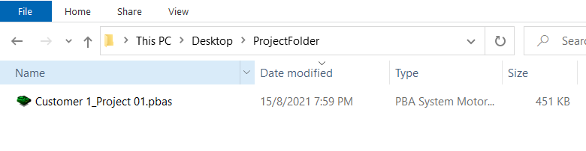

* Step 3

Click Open and Selected project will be loaded to the PBA motor sizer

Save to File

Save to file will create a file from the prpject which can be shared top others.

* Step 1

Click “Save to File” Button

* Opened dialog box will allow to choose the path to save and File name will be auotopouplated with Customer name + Project Name

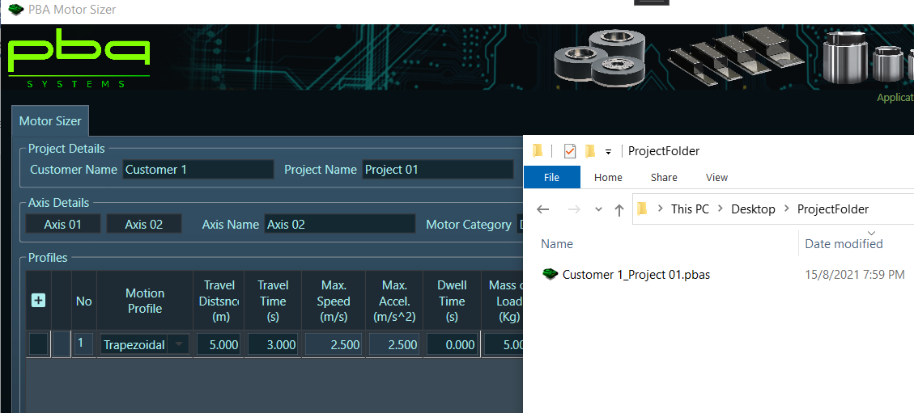

* Press save button

Generate Report

Report will be generated for all the Axises under the project.

* Step 1

Click “Generate Report” Button

* Step 2

Choose the path to save the reports (Please note a report will be generated for each axis)

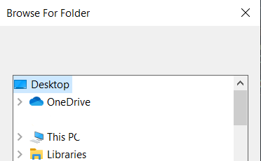

* A folder will be created undet the selected folder with Project name + “Report”

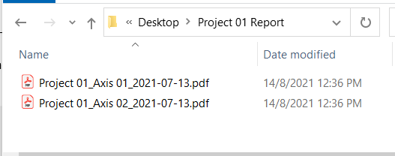

Repoort file name = Project Name + Axis Name + Date

### Validations

Please note all the functions validate two points mentioned below

1. All the axises in the project has to be completed and saves
2. Project name cannot be blank

## 2.Axis

All the claucation will be done under an Axis. There can be multiple axises within a project.

**Axis Panel**

This will list all the axises created and saved within the project/file

### Buttons



* Delete Axis – Delete the selected axis
* Add Axis – Add new axis to the project. This is one of the new feature, which onc file can hold multiples axises.

Delete Axis

Add Axis

Save Axis

* Save Axis – Will save the axis and wil be display the save axis lists

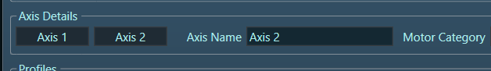

Saved Axises

Selected/Current Axis

## 3.Profile Grid

Profile grid holds all the profiles under selected axis.

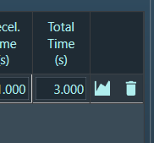

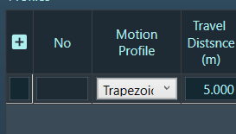

### Buttons



: Add profile - User can add new profile to the profile collection. User can add new prfiles without saving previous profiles.

: Generate Graph – This is buton that can generate on the selected scope.

If the button profile record then it will generate the graph for the relevant

Profile and if the button in the column headeer oit will generate the chart

For all the profiles in the grid.



: Delete Profie – As name suggested can delete the selected profile/s

### Functions **Mutli record Selection**

In the Profile grid press **ctrl + click** on the records will allow the user to select multiple records

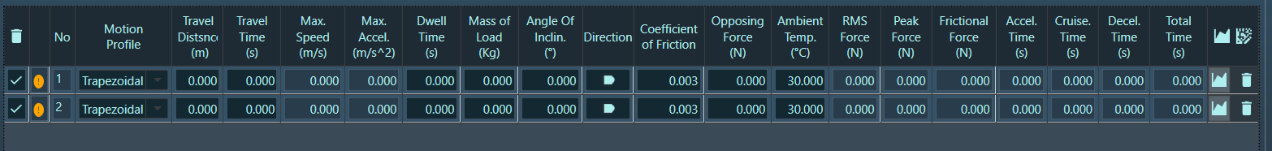

Bulk Delete Buttons

Bulk Edit Button

Bulk Delete button

Bulk delete button will be enabled only when multi record selected and this butto will delete all the selected profiles.

Bulk Edit button

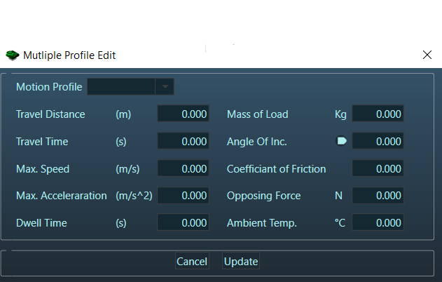

Bulk Edit button will allow users to enter common values for multiples selected records.user can enter the anu value and once press update, whatever the values entered in above screen will be copied to all the profile lines.

## 4.Final Profile

Shows the final calculations required for motor selection.

**Note – All the forces are calculated without considering the Motor mass.**

## 5.Recommended Motors

Shows the recommonended motors based on the calculations in final profile, safety margin and Dcbus voltage

Grid exapllanation

* Motor – Name of the Motor
* Safet Margin – The Motor generated force as percentage from RMS and Peak force

## 6.Selected motors Motors

Field will be desplayes as below

|  |  |  |  |  |
| --- | --- | --- | --- | --- |
| Linear | | | Rotary | |
| DX B, DX F, DX50BE, PIX200, PIX150B, PIX150B , PSM, PSME | CVC, RVCA | UOM | PDDR | UOM |
| Motor : part number | Motor : part number |  | Motor : part number |  |
| Continuous Force | Continuous Force | N | Continuous Torque | Nm |
| Peak Force | Peak Force | N | Peak Torque | Nm |
| Continuous Current | Continuous Current | A | Continuous Current | A |
| Peak Current | Peak Current | A | Peak Current | A |
| Motor Constant | Motor Constant | N/√W | Motor Constant | Nm/√W |
| Force Constant | Force Constant | N/A | Torque Constant | Nm/A |
| Back EMF Constant | Back EMF Constant | V/(m/s) | Back EMF Constant | V/(rad/s) |
| Resistance L-L | Resistance L-L | ohm | Resistance L-L | ohm |
| Inductance L-L | Inductance L-L | mH | Inductance L-L | mH |
| Continuous Power | Continuous Power | W | Continuous Power | W |
| Peak Power | Peak Power | W | Peak Power | W |
| Coil Weight | Coil Weight | Kg |  |  |
| Coil Length | Stroke | mm | DDR Diameter | mm |
| Attractive Force |  | N |  |  |

## 6.Final calculation based on the Selected Motor

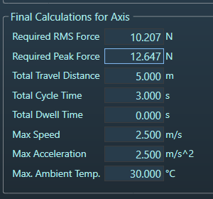Calculated values for the selected motor to determine suitability of the selected motor.

## 8.Servo Drive

Based on the calculated motor parameters (Peak current and Continuous Current) servo drive will be selected

